

**Dr. Hardeep Singh, Sikh – Eco Sikh UK**

**Why do you care for the earth?**

The Sri Guru Granth Sahib Ji teaches us that after the creator creates the creation, it doesn’t abandon it, but resides with it to continually sustain it. The earth is referred to by Sikhs as a shrine for meditation. We are taught that air is the Guru, water is the father and Earth is our mother. Guru, father, mother deserve the utmost respect as they meet our basic needs in life. This is why we care for the Earth – it is our dharmic duty to serve the air, water and earth which is akin to serving God.

**How has your faith inspired your action on climate change and environmental issues?**

Sikhs are inspired by the example of the 7th Guru – Guru Har Rai Ji. He was an environmentalist… When he was a child, he knocked a flower off its stem and was so deeply hurt by this that he never plucked a flower or leaf for the rest of his earthly presence and became an intense lover of nature. He created numerous gardens, wildlife sanctuaries, planted many fruit orchards, created veterinary hospitals… He was the embodiment of humility in service of nature.

In the Guru Granth Sahib Ji it says, ***‘Amidst the creation he established the Earth, a shrine for the Lord’s meditation.’*** The Earth is a holy place and if the creator lives in creation, caring and sharing it is the way to serve and connect with the creator.

**What do you do to put these beliefs into action?**

We’ve done the following projects:

- Plastic free campaigns in gurdwaras – Planted 1000s of trees, as part of the EcoSikh international Guru Nanak Sacred Forest initiative to plant 1 million trees worldwide – Created 3 ‘Oneness groves’ in collaboration with Forestry England in Yorkshire, East Midlands and London – Engagement in COP26 in Glasgow - Webinars, radio, local TV engagement with faith based green charities to inspire one another and share ideas – Cleaning canals in collaboration with The Canal and River Trust - Yearly online EcosikhUK conference - Creation of a wildlife corridor in Glasgow in collaboration with Interfaith Glasgow - Creation of environmental literature for schools and Sikh congregations.

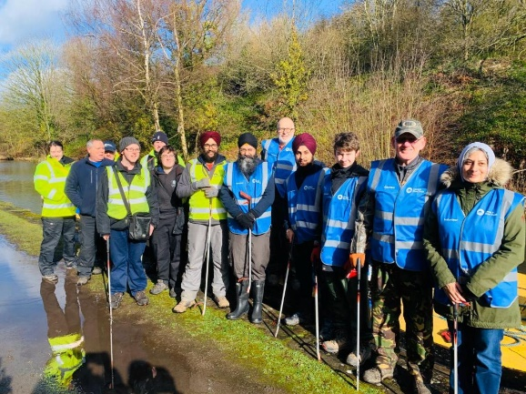

**Community Canal Clean Up – Smethwick, Birmingham**